Dagwaagwin
Fall
Aniibiish
Leaf
Aniibiishan
Leaves
Aniibiishan bangisin
Leaves falling
Adisan
Color it
Adisanan
Colors

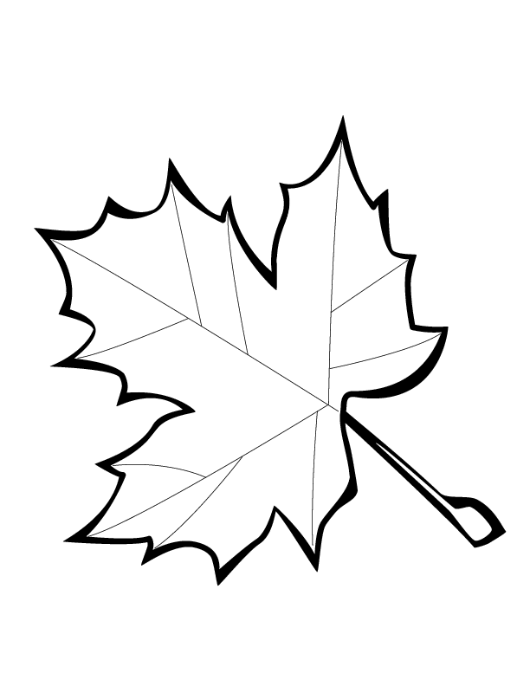
Ingodwaaswi
Naanan
Niishwaaswi
Niiwin
Niswi
Niizh
Bezhig
Zhaangwaaswi
Nishwaaswi

Ozaawaa
Ozaawashko
Oginiiwaande
Waabijiiyaa
Misko
Ozaawashko
Ozaawi
Ozaaw
Miinaande

Aniibiish
Leaf

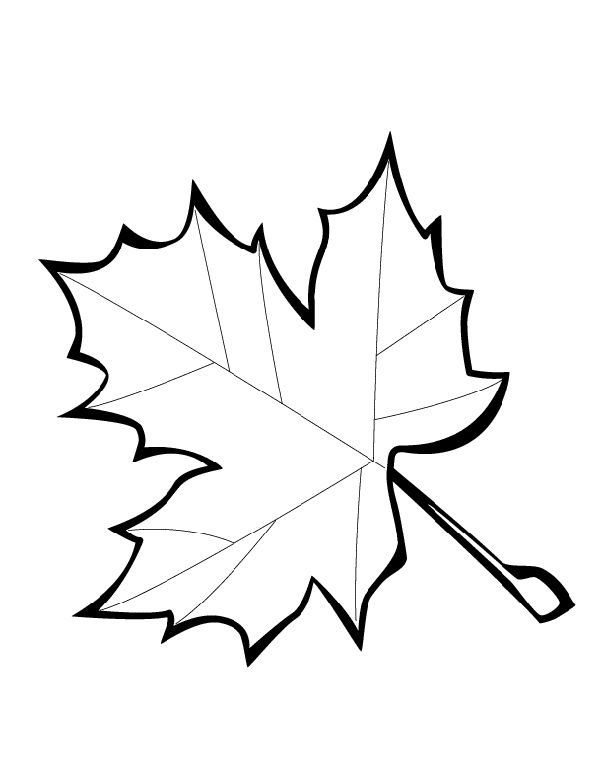

Aniibiishan
Leaves

Aniibiish
Aniibiishens

